**Stakeholder Management Strategy**

**RAMS Corner Ticketing System**

**Nacor Industries**

**Humabon Place, Magallanes,**

**Makati City 1232**

**April 13, 2023**

**Table of Contents**

1. Introduction 3

2. Identify Stakeholders 3

3. Key Stakeholders 4

4. Stakeholder Analysis 5

# Introduction

The Stakeholder Management Strategy for the project is a crucial aspect of effective project management. It involves identifying and engaging with all relevant stakeholders to ensure their interests, concerns, and expectations are considered and addressed throughout the project's lifecycle. In this section, we will discuss the goals and objectives of the Stakeholder Management Strategy and highlight its significance in project success.

Proper stakeholder management is essential as it helps in gaining support and buy-in from stakeholders, while also proactively addressing any potential resistance, conflict, or competing objectives. By actively involving stakeholders, we can minimize risks and maximize project success by aligning their interests with the project's objectives.

In this section, we will outline the key goals and objectives of the Stakeholder Management Strategy, which will serve as a guiding framework for effectively managing stakeholders throughout the project's duration.

Strategies that could be implemented to improve the stakeholder management for the RAMS Corner Ticketing Software System:

* **Communicate regularly and transparently:** The team Nacor Industries will establish an open and transparent communication channel with stakeholders. Provide regular updates on project progress, risks, and changes. Be clear, honest, and consistent in communication to build trust and maintain positive relationships with the stakeholders.
* **Involve stakeholders in decision-making:** Involving stakeholders in the decision-making of the project RAMS Corner can foster their ownership and commitment to the project. Seek their input, feedback, and suggestions when making important decisions, and incorporate their perspectives as appropriate.

By implementing these strategies, our team can improve stakeholder management and cultivate positive relationships with stakeholders, leading to greater project success and organizational effectiveness for the Project RAMS Corner.

# Identify Stakeholders

Stakeholder analysis was used by the project team to identify the project's stakeholders and highlight the ways in which they demonstrate their "proposed actions" for the project's advancement. This may include their impact, influence, engagement techniques, and how they primarily impact the project development lifecycle, such as if they caused delays in particular development phases or brought success and failure with their suggested activities.

Identified Stakeholders:

1. Project Sponsor

* Mr. Jose Castillo, as the head of the ITRO department office, facilitates discussions among the project team providing the necessary technical aspects needed for system development. He is also identified as the project sponsor.

1. Project Advisor

* The project advisor is Mr. Alvin Limpin. With his extensive knowledge and experience in the corporate field and the IT industry, he was able to provide guidance to the project's development by highlighting technical uncertainties within the system. This has a significant impact on the project team because the suggested changes and updates took time to implement, resulting in delays in the project's development.

1. Project Consultant

1. Mr. Hans Schuck

2. Ms. Wednesday Gardon

* Both Project Consultants are also identified as project stakeholders since they are defined by their influence made in the team as the gave insights and suggestions towards their field of expertise which give them a lot of credit to the project contribution

1. APC ITRO

* APC ITRO is identified as a project stakeholder since they provide continuous feedbacks upon the accessibility and usability of the Ticketing System, which they fill a big role as the staff who will use the system as the development team will turnover the full working system for the ITRO Department Offie specific use case.

5. APC Students and Faculties

* Students and faculties are identified as project stakeholders since they are the specific users of the Ticketing System, in which they will utilize to further communicate with ITRO customer service using the Ticketing System and using the application will be their greatest contribution as they provide with the feedback and usability of the system.

# Key Stakeholders

Identified Key Stakeholders:

1. ITRO Department Office of Asia Pacific College Headed by Mr. Jose Castillo

* One of the key stakeholders in the Project entitled Rams Corner Ticketing System is the ITRO Department Office. On top of that, they said the department office also happens to be the project's client, which is under the supervision of Mr. Jose Castillo. After the whole project development is complete, the ticketing software as the byproduct of the project will be utilized by the department. The head of the ITRO Department Office, Mr. Jose Castillo is the representative of the department that facilitates communication between the project team including all the discussions, meetings, updates, with his great knowledge in technical field of information technology he managed to bring great impact and influence towards the decision making with regards to the development during the course of the project.

# Stakeholder Analysis

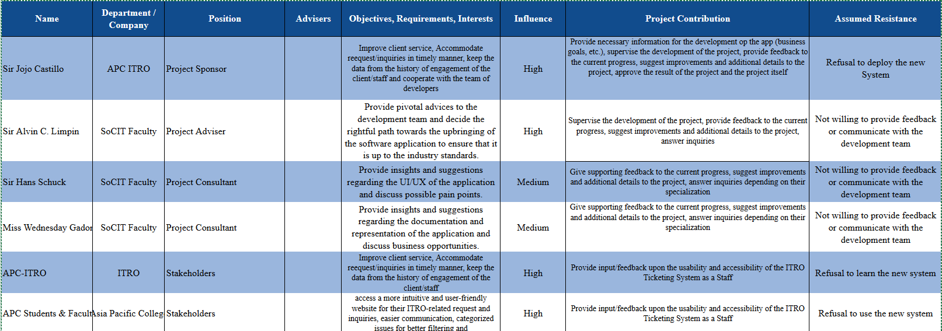

**Sponsor Acceptance**

Approved by the Project Sponsor:

Date:

<Project Sponsor>

<Project Sponsor Title>

This free Stakeholder Management Strategy Template is brought to you by [www.ProjectManagementDocs.com](http://www.ProjectManagementDocs.com)